ReactJS Hands-on 3 - Score Calculator App

Project Structure
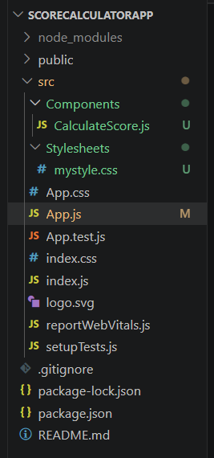

CalculateScore.js
import "../Stylesheets/mystyle.css";
const percentToDecimal = (decimal) => {
return (decimal * 100).toFixed(2) + "%";
};
const calcScore = (total, goal) => {
return percentToDecimal(total / goal);
};
export const CalculateScore = ({ Name, School, total, goal }) => {
return (
<div className="formatstyle">
<h1>Student Details:</h1>
<div className="Name">
<b>Name:</b><span> {Name}</span>
</div>
<div className="School">
<b>School:</b><span> {School}</span>
</div>
<div className="Total">
<b>Total:</b><span> {total} Marks</span>
</div>
<div className="Score">
<b>Score:</b><span> {calcScore(total, goal)}</span>
</div>
</div>
);
};

mystyle.css
.Name{
font-weight:300;
color:blue;
}
.School{
color:crimson;
}
.Total{
color:darkmagenta;
}
.Score{
color:forestgreen;
}
.formatstyle{
text-align:center;
font-size:large;
}

App.js
import { CalculateScore } from "./Components/CalculateScore";
function App() {
return (
<div>
<CalculateScore
Name="Steve"
School="DNV Public School"
total={284}
goal={3}
/>
</div>
);
}
export default App;

Expected Output
Student Details:
Name: Steve
School: DNV Public School
Total: 284 Marks
Score: 9466.67%
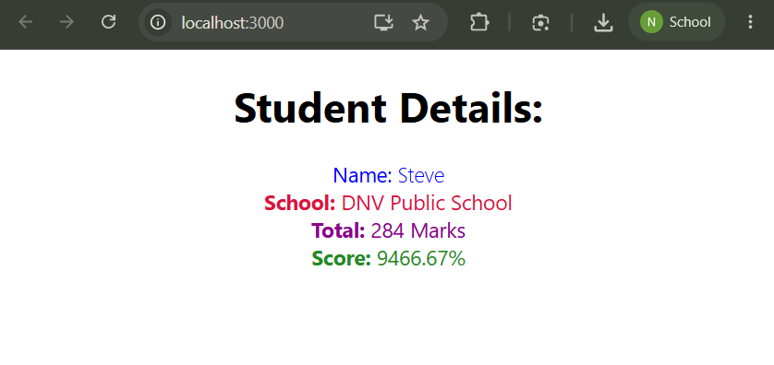

Result
The scorecalculatorapp React application was created successfully. The CalculateScore functional component calculated the score and displayed the student details with CSS styling.

